
Sky Smart Technology (Pvt) Ltd

Sustainability Web Application

Activity Diagrams
for
Health and Safety Module

Version 1.0

Date : 05/03/2025

Table of Contents
1. Accident Management 3
2. Incident Management 4
3. Report a New Hazard Risk 5
4. Document Management 6
5. Occupational Health 7
5.1 Occupational Health – Clinical suite 7
5.2 Occupational Health – Medicine Inventory 8
5.3 Occupational Health-Purchase Inventory 9
5.4 Occupational Health – Maternity Register 10

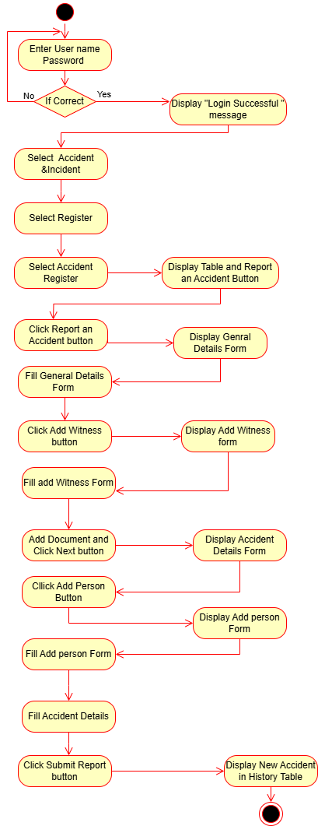
Accident Management

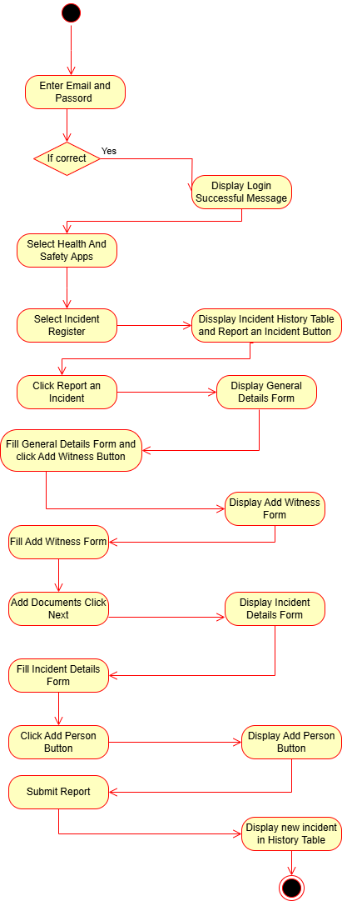
Incident Management

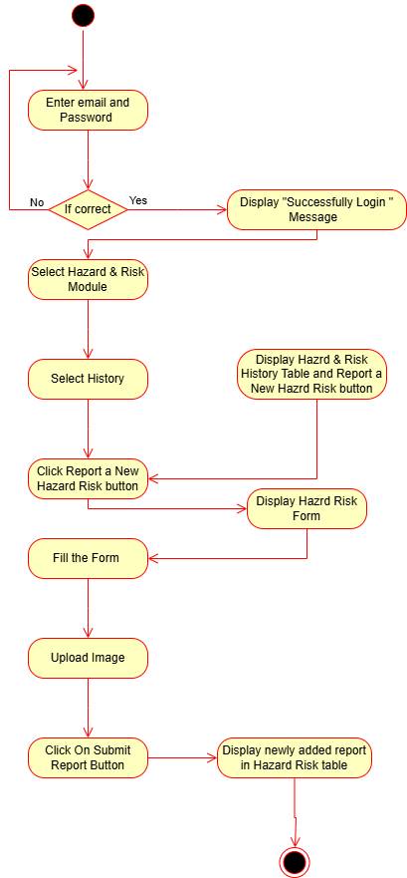
Report a New Hazard Risk

Document Management
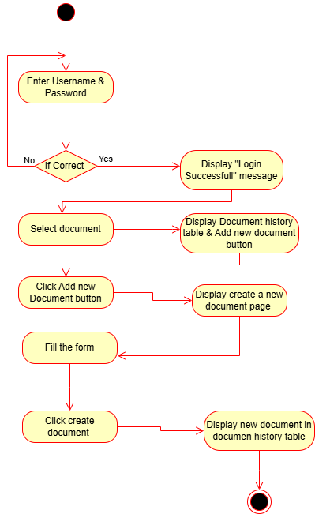

Occupational Health

5.1 Occupational Health – Clinical suite
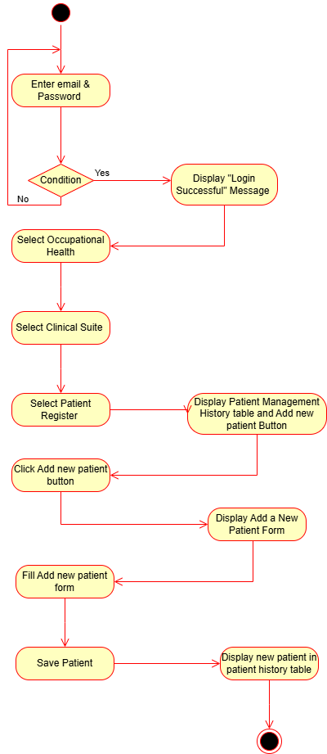

5.2 Occupational Health – Medicine Inventory
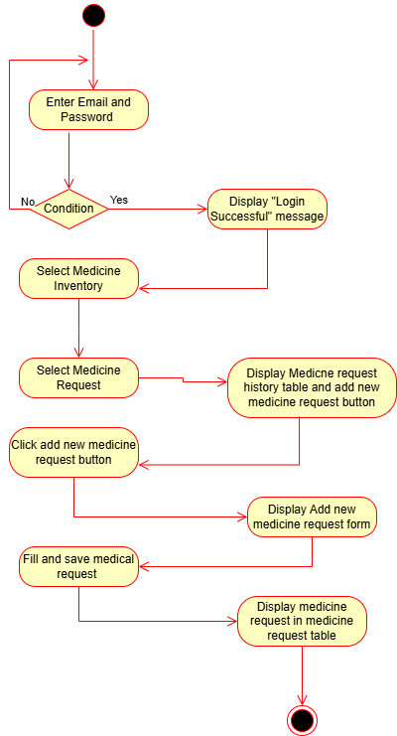

5.3 Occupational Health-Purchase Inventory
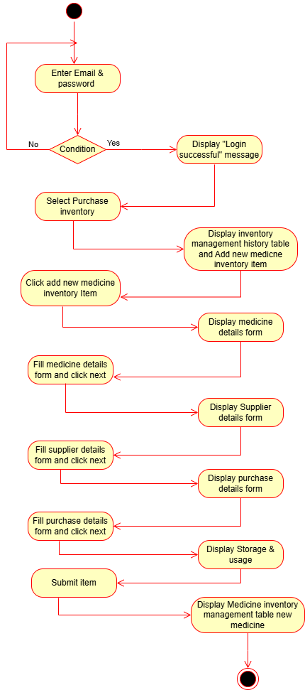

5.4 Occupational Health – Maternity Register
